Code Implementation – Hosting the AI Model API

This week, I found an AI model on [Huggingface](https://huggingface.co/turhancan97/yolov5-detect-trash-classification) that uses Yolov5 for trash classification; it was trained on a dataset of over 120k images from COCO, Trashnet, and TACO. This model would suit my project if I did not make a model myself. I have tested it extensively and used it as part of another project. Overall, the model has an 80% average accuracy, classifying plastic bottles and tin cans extremely well especially when they are isolated.

To use the AI model offline, I downloaded the weights file from the Hugginface repo, which you can find [here](https://huggingface.co/turhancan97/yolov5-detect-trash-classification), then I created a class that will load the model using YOLOV5 and openCV library and configured the model according to the documentation. Finally, I created a method called classify, which takes an image as a parameter and uses the model to make inferences.

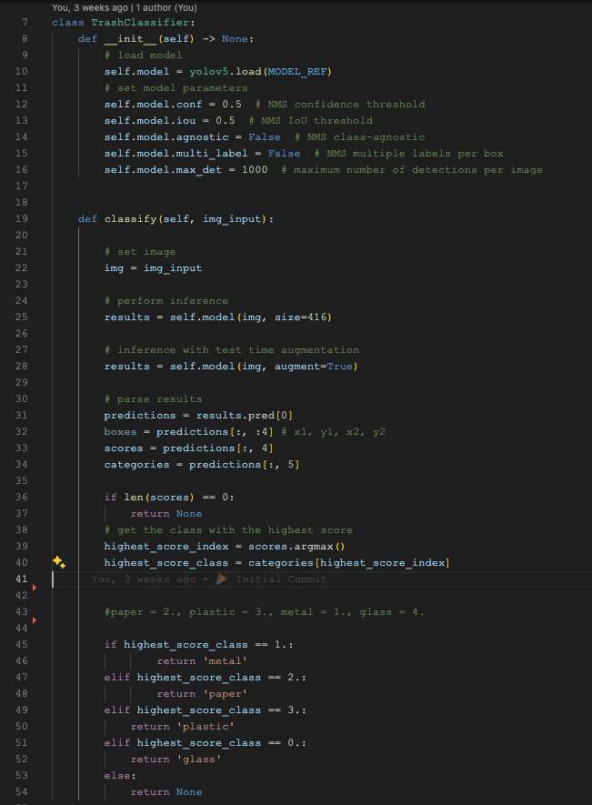

These are some of the results after inference:

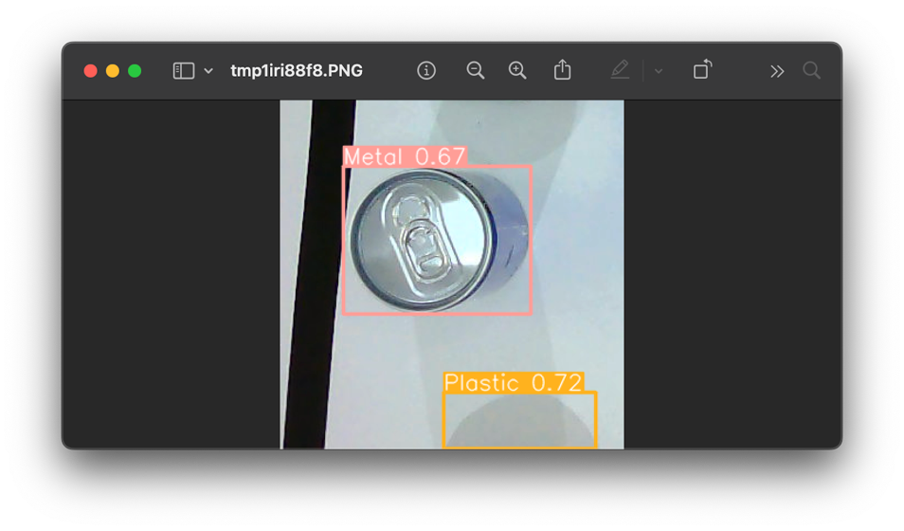

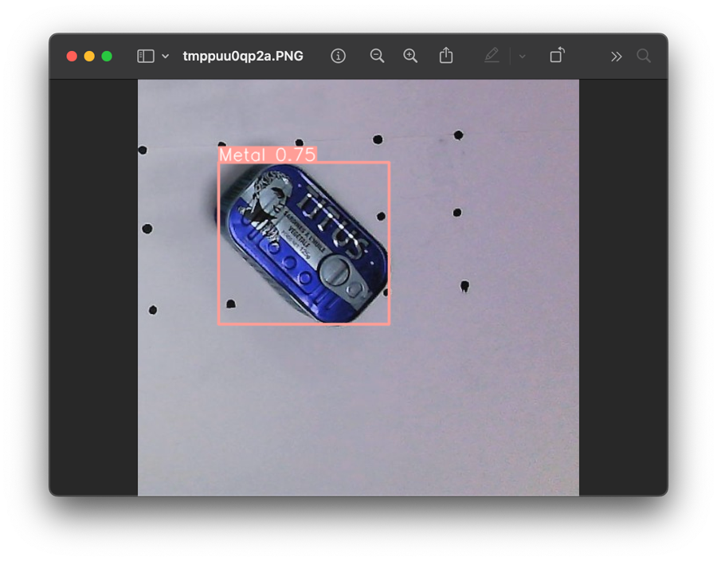

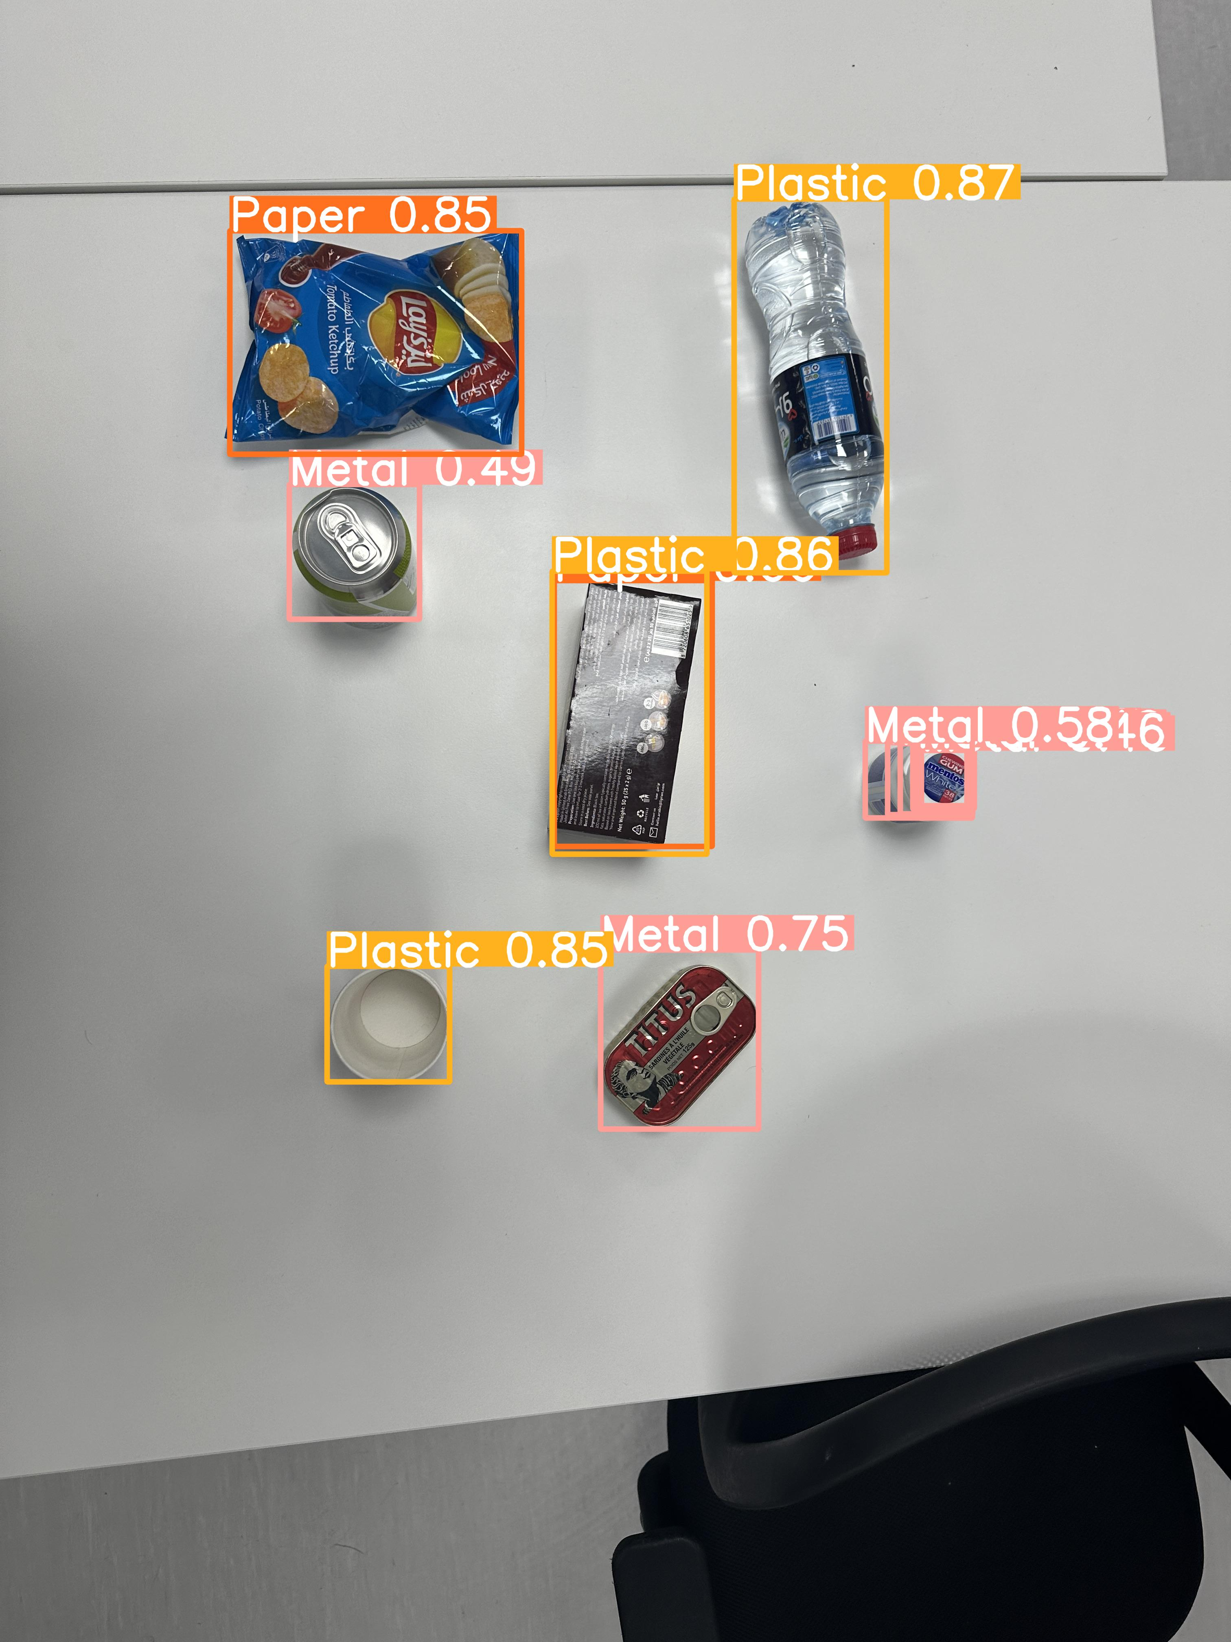

After testing the AI model, I decided to move ahead and host it via an API to access it from my ESP32 Cam + WIFI module or my Arduino Uno R4 WIFI. I used FastApi, a Python-backend REST framework, to host the API; initially, I thought it worked quite well on my local device while developing it but pushing it to the cloud for hosting was challenging. It is either very expensive to find a cloud server to host the API requirement, or I face many dependency issues. I ended up using Railway, an online cloud provider for building, monitoring, and shipping applications. So far, as I am writing this blog, I have been facing issues with the OpenCV library as a dependency.

# Project Update

1. Started 3D printing parts for my prototype.
2. Purchased more parts for the prototype.
3. Found and integrated an AI model for detecting waste
4. Found a backend framework to host my API model.
5. Trying to host the model in the cloud for https access (Currently facing dependency issues)

# Reflection

This week, I found FastApi. To be fair, I thought setting up the backend for this project would take me a long time, but thanks to FastApi documentation and ease-of-use I was able to set the model to work via an API locally in a single night! I am so glad I found FastApi, anyone looking for a backend framework for hobby projects should use FastApi.